Bildagentur für Kunst, Kultur und Geschichte.

Ahmad Hasan Ahmad

2023-04-27

Table of contents

# 1. Kunsthistorisches Museum

Author: Ahmad Hasan Ahmad

ORCID: https://orcid.org/0009-0008-4964-222X

Date: 28.04.2023

DOI: 10.5281/zenodo.7873444

Repository URL: https://github.com/Ahmad19111/catalogue-003

## 1.1 Based on Baroque AI: Publication Prototype

## 1.2 Part of the series: Baroque TOC

[Programme instructions](https://nfdi4culture.github.io/class-ADA-CP-pipeline/)

2023-03-17

This work is licensed under a Creative Commons Attribution-ShareAlike 4.0 International License.

Book cover: Reworking of [Baroque pearl with enamelled gold mounts set with rubies](https://en.wikipedia.org/wiki/File:Pendant_in_the_form_of_a_siren_MET_DT7173.jpg). Creative Commons CC0 1.0 Universal Public Domain Dedication. This file was donated to Wikimedia Commons as part of a project by the Metropolitan Museum of Art.

This work is licensed under a Creative Commons Attribution-ShareAlike 4.0 International License.

# 2. Colophon

* Fork title: Ahmad19111/catalogue-003
* Author: Ahmad Hasan Ahmad
* ORCID: https://orcid.org/0009-0008-4964-222X
* Date: 28.04.2023
* DOI: 10.5281/zenodo.7873444
* Repositor: https://github.com/Ahmad19111/catalogue-003

PUBLISHING FROM COLLECTIONS USES OF COMPUTATIONAL PUBLISHIGN AND LINKEDOPEN DATA

Open Science Lab - TIB Hannnover

First published 2023-03-30

Copyright © The Authors 2023 Licensed as https://creativecommons.org/licenses/by-sa/4.0/

DOI: https://doi.org/10.5281/zenodo.7701161

# 3. About the Museum

Source: https://de.wikipedia.org/wiki/Bildagentur_f%C3%BCr_Kunst,_Kultur_und_Geschichte

### 3.0.1 Bildagentur für Kunst, Kultur und Geschichte

The Picture Agency for Art, Culture and History (bpk) is an institution of the Prussian Cultural Heritage Foundation and was founded in 1966 as the Picture Archive of Prussian Cultural Heritage. The photo agency is housed in a house named after Otto Nagel on the Märkisches Ufer in Berlin’s Mitte district and claims to have twelve million photos, caricatures and drawings from the fields of art, culture and history.

In organizational terms, the photo agency is a department of the Berlin State Library.

Karen Tieth has been the head of bpk since January 2019.

# 4. Data Visualization

Visualization

Here an image of my data viz : 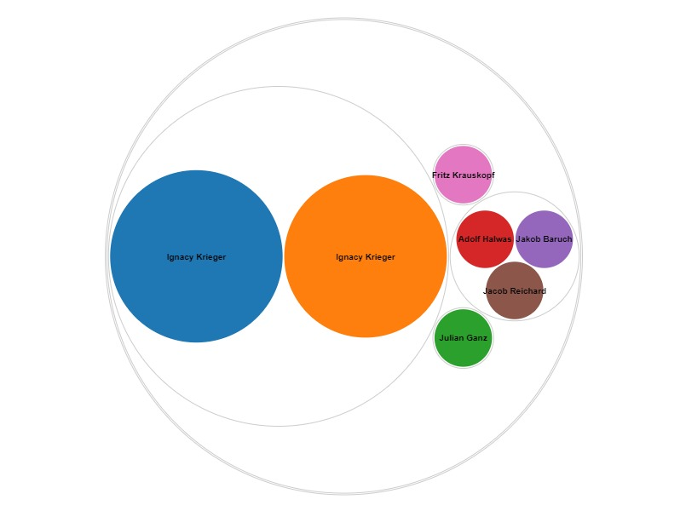

Here is an iframe with some data viz:

# 5. Historischer Porträtaufnahmen

Wikidata link: <http://www.wikidata.org/entity/Q119217955>

Title: Polish Rabbi

Year: 1870-01-01T00:00:00Z

Creator: Ignacy Krieger

Collection: Bpk-Bildagentur

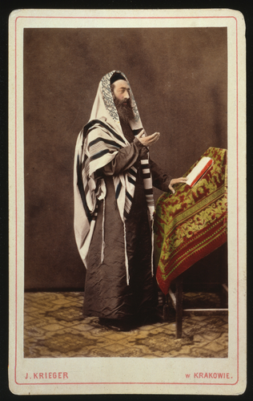

Wikidata link: <http://www.wikidata.org/entity/Q119217956>

Title: Young Pole in national dress from Lublin region

Year: 1870-01-01T00:00:00Z

Creator: Ignacy Krieger

Collection: Bpk-Bildagentur

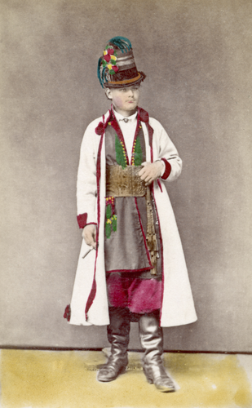

Wikidata link: <http://www.wikidata.org/entity/Q119217957>

Title: Old man from Plotska area

Year: 1870-01-01T00:00:00Z

Creator: Ignacy Krieger

Collection: Bpk-Bildagentur

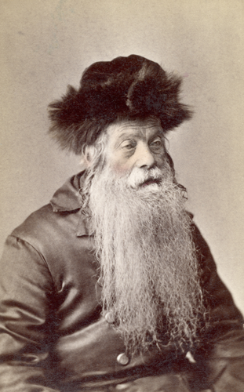

Wikidata link: <http://www.wikidata.org/entity/Q119217958>

Title: Polish couple in national costume

Year: 1870-01-01T00:00:00Z

Creator: Ignacy Krieger

Collection: Bpk-Bildagentur

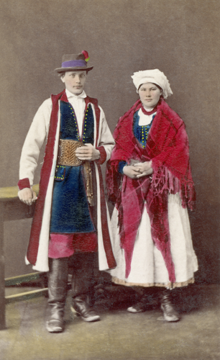

Wikidata link: <http://www.wikidata.org/entity/Q119217959>

Title: Male costume from the Lublin area

Year: 1870-01-01T00:00:00Z

Creator: Ignacy Krieger

Collection: Bpk-Bildagentur

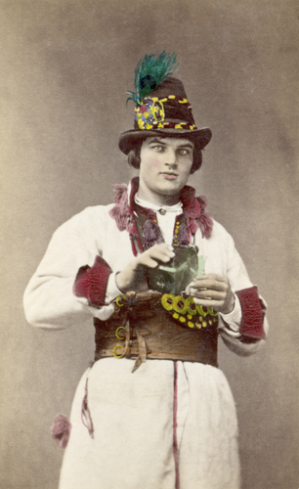

Wikidata link: <http://www.wikidata.org/entity/Q119217961>

Title: children’s costume

Year: 1870-01-01T00:00:00Z

Creator: Ignacy Krieger

Collection: Bpk-Bildagentur

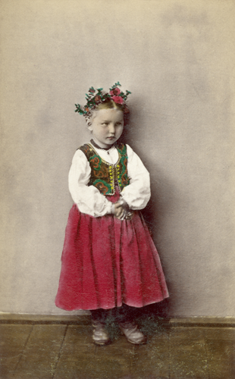

Wikidata link: <http://www.wikidata.org/entity/Q119217962>

Title: women’s costume

Year: 1870-01-01T00:00:00Z

Creator: Ignacy Krieger

Collection: Bpk-Bildagentur

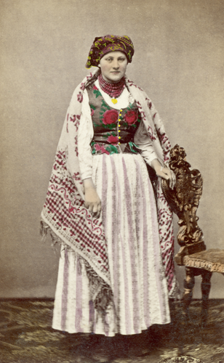

Wikidata link: <http://www.wikidata.org/entity/Q119217987>

Title: Couple in Sunday costume

Year: 1870-01-01T00:00:00Z

Creator: Ignacy Krieger

Collection: Bpk-Bildagentur

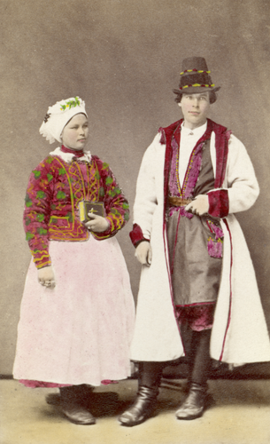

Wikidata link: <http://www.wikidata.org/entity/Q119224407>

Title: Couple in holiday costume

Year: 1870-01-01T00:00:00Z

Creator: Ignacy Krieger

Collection: Bpk-Bildagentur

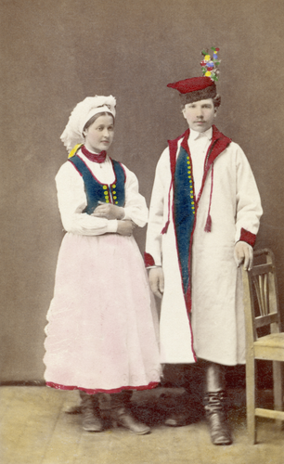

Wikidata link: <http://www.wikidata.org/entity/Q119224408>

Title: Festival costume of a young farmer

Year: 1880-01-01T00:00:00Z

Creator: Ignacy Krieger

Collection: Bpk-Bildagentur

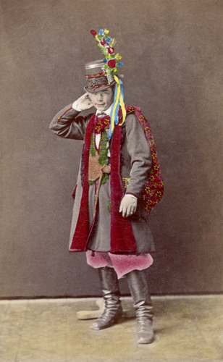

Wikidata link: <http://www.wikidata.org/entity/Q119224410>

Title: Clothes of a landowner from the Lublin area

Year: 1880-01-01T00:00:00Z

Creator: Ignacy Krieger

Collection: Bpk-Bildagentur

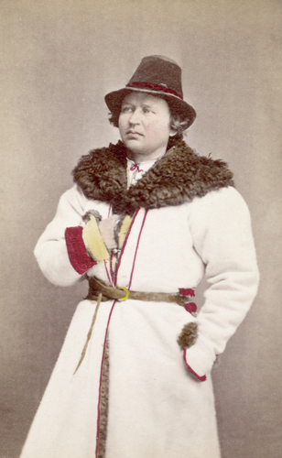

Wikidata link: <http://www.wikidata.org/entity/Q119224411>

Title: Itinerant saleswoman with wall mats

Year: 1880-01-01T00:00:00Z

Creator: Ignacy Krieger

Collection: Bpk-Bildagentur

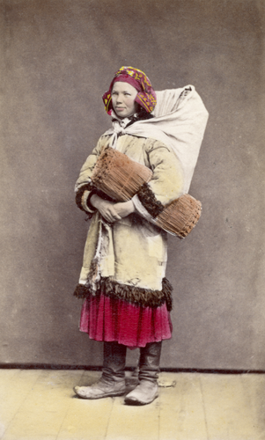

Wikidata link: <http://www.wikidata.org/entity/Q119224412>

Title: Costume of a Warsaw student

Year: 1880-01-01T00:00:00Z

Creator: Ignacy Krieger

Collection: Bpk-Bildagentur

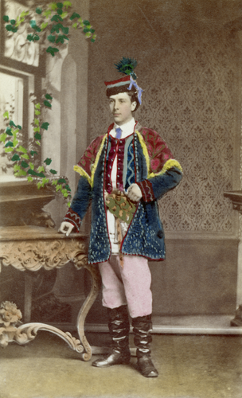

Wikidata link: <http://www.wikidata.org/entity/Q119224414>

Title: Coachman’s clothing

Year: 1880-01-01T00:00:00Z

Creator: Ignacy Krieger

Collection: Bpk-Bildagentur

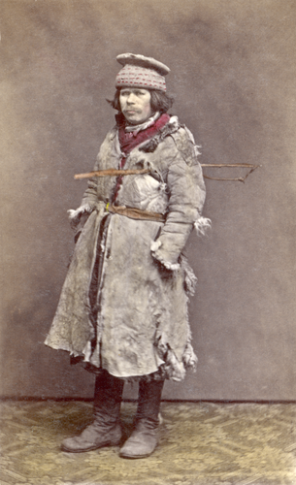

Wikidata link: <http://www.wikidata.org/entity/Q119224417>

Title: Costume of a peasant girl

Year: 1880-01-01T00:00:00Z

Creator: Ignacy Krieger

Collection: Bpk-Bildagentur

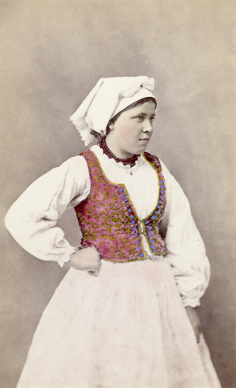

Wikidata link: <http://www.wikidata.org/entity/Q119224419>

Title: Shepherd’s costume

Year: 1880-01-01T00:00:00Z

Creator: Ignacy Krieger

Collection: Bpk-Bildagentur

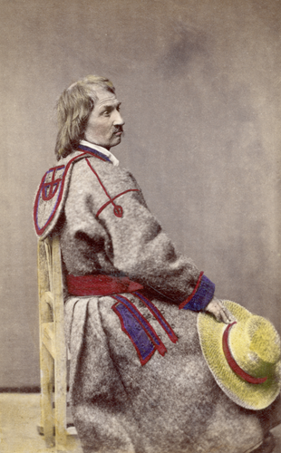

Wikidata link: <http://www.wikidata.org/entity/Q119224499>

Title: costume of a farmer

Year: 1880-01-01T00:00:00Z

Creator: Ignacy Krieger

Collection: Bpk-Bildagentur

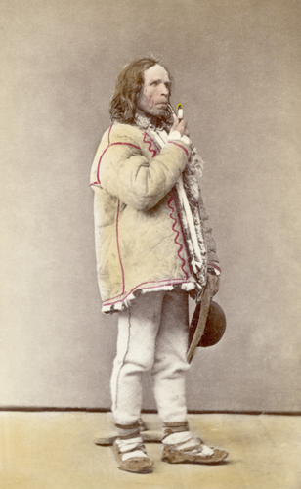

Wikidata link: <http://www.wikidata.org/entity/Q119224500>

Title: David Popper

Year: 1873-01-01T00:00:00Z

Creator: Julian Ganz

Collection: Bpk-Bildagentur

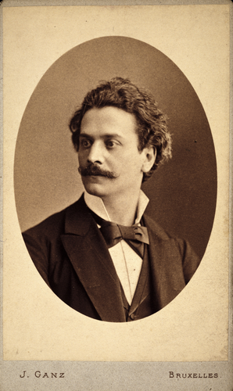

Wikidata link: <http://www.wikidata.org/entity/Q119224502>

Title: Max Bruch

Year: 1895-01-01T00:00:00Z

Creator: Adolf Halwas

Collection: Bpk-Bildagentur

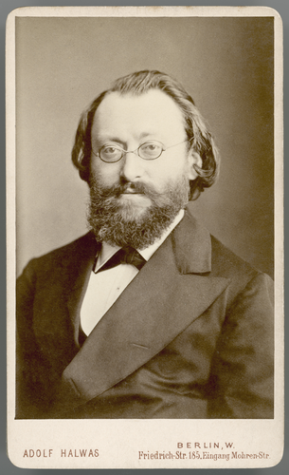

Wikidata link: <http://www.wikidata.org/entity/Q119224503>

Title: Gerhart Hauptmann

Year: 1889-01-01T00:00:00Z

Creator: Jakob Baruch

Collection: Bpk-Bildagentur

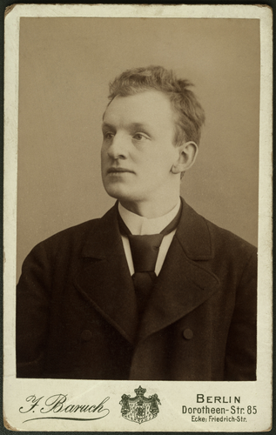

Wikidata link: <http://www.wikidata.org/entity/Q119224504>

Title: Hermann Ludwig Ferdinand von Helmholtz

Year: 1881-01-01T00:00:00Z

Creator: Jacob Reichard

Collection: Bpk-Bildagentur

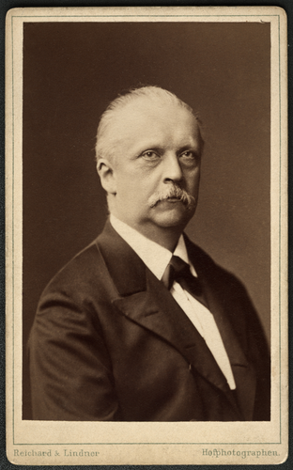

Wikidata link: <http://www.wikidata.org/entity/Q119224506>

Title: “Old gentleman” with student cap

Year: 1910-01-01T00:00:00Z

Creator: Fritz Krauskopf

Collection: Bpk-Bildagentur

